2020 District 5 Virtual Share-the-Fun Talent Showcase and Theater & Performance Arts Educational Components

Program Purpose
- To provide District 5 4-H youth an avenue to present/showcase their creative talents and receive feedback/critique to be used for future Share-the-Fun contests.
- Free educational activities/videos will be provided via the District 5 Texas 4-H Facebook page on the following dates:
  - April 27 – Lesson 1: Using your imagination to create characters and props
  - April 28 – Lesson 2: Stage presentation and tips for body language and voice to portray a variety of characters in theatre production.
  - April 29 – Lesson 3: Theater dynamics and understanding drama, characters, plat, setting, conflict, climax and resolution.
  - April 30 – Lesson 4: Developing character roles and how to use emotion and character
history development to create scenes using improvisation.
  - May 1 – Lesson 6: Auditions and how to demonstrate performance skills.

Talent Showcase Date
Saturday, June 6, 2020

Time
To be determined

Location
Virtually on the District 5 Texas 4-H (Facebook group) OR Youtube (information to be provided at a later date).

Talent Showcase Categories (see page 3 for specific information)
- Choreographed Routines
- Dramedy
- Poetry/Prose
- Vocal
- Celebrate 4-H
- Musical/Instrumental
- Solo/Band Performance

Entry Requirements
  - Enter individually on 4-H Connect beginning April 9, 2020 at https://texas.4honline.com
  - Talent Showcase Participation Fee - $10 per participant per entry

District Deadlines
  - Registration on 4-H Connect by May 25, 2020
  - No late registrations accepted

Entry Divisions (grade by August 31, 2019)
  - Junior Grades 3, 4, and 5
  - Intermediate Grades 6, 7, and 8
  - Senior Grades 9, 10, 11 and 12

Broadcast Schedule
- Schedule may be modified based upon number of participants.
- Specific times for each broadcast of the talent show will be sent to county Extension agents ONE week before event. Final schedule will be posted on the district website at D54-H.tamu.edu and on the district Facebook page at District 5 Texas 4-H

Feedback
- County agents serving on the Share-the-Fun committee will review the submitted presentations and provide feedback to participants via 4-H scorecards.
- A popular vote option will be available during the live broadcast for viewers to provide 1 vote per email/text number for each category and age division.

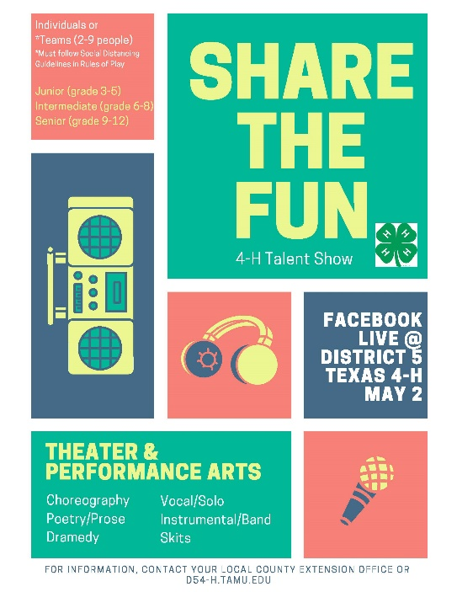
Share-the-Fun is a competitive event related to the Theater and Performance Arts project. 4-H members have the chance to develop a spirit of cooperation with their fellow 4-H members; develop self-confidence through public performance; stimulate interest in broad-based recreation in 4-H clubs; encourage 4-H members to discover and develop their talents and to grow socially, culturally, and further develop leadership skills.
share-the-fun TALENT SHOWCASE
Entry
- Enter as an individual and/or a team of 2 to 9 members.
- Teams must practice social distancing guidelines.
  - Work with other team members virtually to record your program. Heres’ a great example of making group bands at a distance work. https://www.facebook.com/janisjoplin/videos/208153353784973/UzpfSTEwMTQzNjk3Nzk0MjQzMjoyMDk5MjQ0NTcwOTM2ODM/?modal=admin_todo_tour
  - Or develop a presentation with siblings or other members of your household,
- Mixed age division teams following social distancing guidelines are permitted.

Categories
- Choreographed Routines
  - The act requires choreography and can be demonstrated through twirling, pom-pom squad routines, jump rope teams, basketball dribbling exhibitions, or dance (jazz, tap, country & western, ballroom, etc.).
  - Sign language presentations to music have been added to choreographed routines. However, if a participant is SINGING and SIGNING, this entry should be entered in the Vocal Category.
  - No speaking to form a skit or story line.
  - All 4-H members entered in the category must be a part of the act.
  - Acts may use recorded music on CD or digital music player but may not use an accompanist.

- Dramedy
  - This is an acting category. A dramedy (also known as a comedy-drama or comedic drama) is an act that combines elements of comedy and drama, having both humorous and sometimes serious content.
  - Acts cannot incorporate 4-H related material or theme. (Otherwise, it would be categorized as Celebrate 4-H).
  - Skits can be currently available scripts, original material, or a combination of the two.
  - Humor and creativity are encouraged, but the degradation of any individual or organization is not permitted.
  - May incorporate music, vocal selections, and/or choreographed routines, but these aspects cannot be more than half of the performance.

- Poetry/Prose
  - Acts which showcase poetry or prose are required.
  - The act may NOT incorporate vocal, musical, and/or choreographed routine.
  - This category does not require 4-H related material, however, if an original poem or prose piece showcasing 4-H is written, this would be acceptable.
  - Every 4-H member entered in the category must be a part of the performance on stage.
  - All material must be memorized. No script may be used during the performance.
  - Judged on material chosen, message, talent, presentation style, props/costuming.
  - Definitions
    - Poetry is generally characterized by structured meter and rhyme that tells a story or provides a message to the reader.
    - Prose is distinguished from poetry by its greater variety of rhythm and its closer resemblance to the patterns of everyday speech. Another description might be an excerpt from a larger piece such as a play or book.

- Vocal
  - Vocal presentation may be done a cappella or with an accompaniment CD, iPod, or other mp3 player.
  - No accompanist will be allowed for this category.
  - All members in the act must be singing.
  - No lip sync will be allowed.
  - Contestants may not present skits, poetry or other speaking during the act. They may, however, move around the stage and incorporate choreography with their presentation for the purpose of enhancing their showmanship.
  - Sign language may be added to enhance the performance, but entries that strictly showcase sign language without vocal presentation are not permitted in this category, they must be entered in choreographed routines.

- Celebrate 4-H
  - May be a 4-H based story line, promoting 4-H, community service, a project or activity.
  - This category may also address a specific youth issue and present ways in which this issue can be addressed through 4-H efforts.
  - May incorporate music, vocal selections, and/or choreographed routines but these aspects cannot be more than half of the performance.
  - Skits can be humorous, creative but cannot make fun of others or the 4-H program.
  - All 4-H members entered in the category must be a part of the act.

- Musical/Instrumental
  - Musical presentation may be musical instruments accompanied by background recorded music or an instrumental performance only.
  - No accompanist will be allowed.
  - Participants may not sing or incorporate a skit, poetry, prose, or choreography with their act.

- Solo/Band Performance
  - This act incorporates a combination of vocal and musical/instrumental talents.
  - Acts that are vocal only or musical/instrumental only are not to be entered in this category.
  - All 4-H members entered in the category must be a part of the act by playing a musical instrument, singing, or both (solo performance must play an instrument and sing).
  - Participants MUST incorporate singing in the acts, but cannot incorporate skits, poetry, or prose. They may, however, move around the stage and incorporate choreography with their presentation for the purpose of enhancing their showmanship.

Time Limits
- Participants may use up to a maximum of six (6) minutes for presentation.

Props
- Props may be utilized. The following materials may not be used in any category: talcum powder/baby powder, flour, pies, food, water, oil, loose feathers, flower petals, hay, straw, helium balloons, glitter, sand, confetti, open flames or other substances which are hard to clean up, may cause damage, or be dangerous to participants.
- No roller skates, shoes with spikes, cleats, motorized vehicles or live animals will be allowed.
Introduction of the Act
- Contestants will need to introduce themselves.

Adult Assistance - Performance
- During a performance adult coaches may give cues for music backstage and help with costume/prop changes backstage. They are NOT allowed to participate in any other form in the act while the act is going on. Any voices heard during the performance must be either a participant OR a recorded voice.

Required Information Form
- Share-the-Fun contestants must complete and upload the REQUIRED Online Information Form by April 22 to the district office to carolyn.walton@ag.tamu.edu This form can be found at the following link: https://d54-h.tamu.edu/2017-18-contests-events/2019-2020-contests-and-events/2019-20-roundup-district/

