2020 District 5 Virtual Fishing Tournaments
Contest Information

Tournament Species
Bass: Largemouth, smallmouth, spotted, Guadalupe
Crappie: White and black
Catfish: Channel, blue and their hybrids or subspecies and flathead

See link below to learn how to identify specific fish species in Texas.
https://tpwd.texas.gov/landwater/water/aquaticspecies/inland.phtml

Tournaments

Species | Tournament Level | Participation
Bass | State-wide and/or District | Individual and/or team
Crappie | District 5 | Individual
Catfish | District 5 | Individual

Tournament Schedules

Species | Dates | Fishing Times
Bass | March 7, 14, and 21 | 8:00 am – 3:00 pm
Crappie | May 9, 16, and 23 | 8:00 am – 3:00 pm
Catfish | June 5-6, 12-13, and 19-20 | 6:00 pm of day 1 to 6:00 pm of day 2

Location
- Fish anywhere permitted by law (freshwater, ponds, stock tanks, rivers, lakes, etc.).
- Boats are not required.
- Post entry pictures for judging on Facebook during specified dates and times.

Safety and State Fishing Regulations
- Be sure to follow all Texas regulations regarding fishing licenses, bag limits, length requirements and other rules https://tpwd.texas.gov/regulations/outdoor-annual/fishing/
- Each 4-H family entered is responsible for the safety of youth anglers during the tournaments.
Entry Requirements
  - Register on 4-H Connect beginning January 21, 2020 at https://texas.4honline.com
- After registering on 4-H Connect, participants must join the Facebook 4-H Fishing group by clicking here or going to https://www.facebook.com/groups/1202432833284039/
at least 2 days before the tournament begins.
Entry Fees
  - $25 per individual per species tournament (may participate in all three dates for particular species with one-time entry fee).
  - Optional Big Bass individual entry - $5
  - Bass teams are comprised of 3 or 4 members of any 4-H age division (mixed teams are permitted).

District Registration Deadlines
Bass Tournament
  - Entry to 4-H Connect by March 3, 2020

Crappie Tournament
  - Entry to 4-H Connect by April 28, 2020

Catfish Tournament
  - Entry to 4-H Connect by June 1, 2020

Awards
- Presentation of awards for each contest will be held at the county-level at a date determined by county agents.
  - 1st place will be presented a medal and a prize to be determined by 4-H Fishing committee. 2nd and 3rd places will receive a rosette and a prize to be determined by 4-H Fishing committee.
  - If registered in the optional “Big Bass” contest, the top placing big bass (based upon fish length and girth) will be presented a replica of the winning fish.
- Entry via 4-H Connect gives permission to the District office to use the participant’s name and photograph as needed for marketing and promotion purposes.

Educational Opportunities
- 4-H members that join the Facebook 2020 4-H Fishing group, will have the opportunity to view Texas Parks and Wildlife skill-based videos on using fishing gear, selecting lures and other topics of interest.
- Optional weekly skill-a-thon activities will also be available to check a member’s knowledge of fishing skills and techniques.

Tournament and Participation Rules
Bass Tournament (any enrolled 4-H member across the state of Texas may participate in this event) (individual and/or team event)
- Event Dates: March 7, 14, and 21
- Times: 8:00 am to 3:00 pm - postings before or after times will be disqualified.
- Team: A team is comprised of a minimum of 3 members and a maximum of 4 members.
- Bass Species for Judging: Largemouth, smallmouth, spotted, Guadalupe
- Posting Limits: 5 bass. If more are posted, only the first 5 will count.
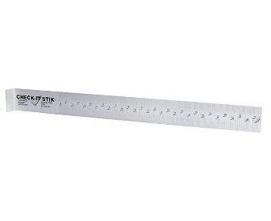
- Judging Criteria:
  - Fish must be photographed laying on a Check-It-Stik measuring board in addition to a completed note card or the optional form below. Check-It-Stiks can be purchased at Academy, on-line and at other fishing gear stores.
  - Mouth of fish must be touching the board and tail pinched. If measurement cannot be read from photograph, the entry will be disqualified. See example below:
Check-It-Stik

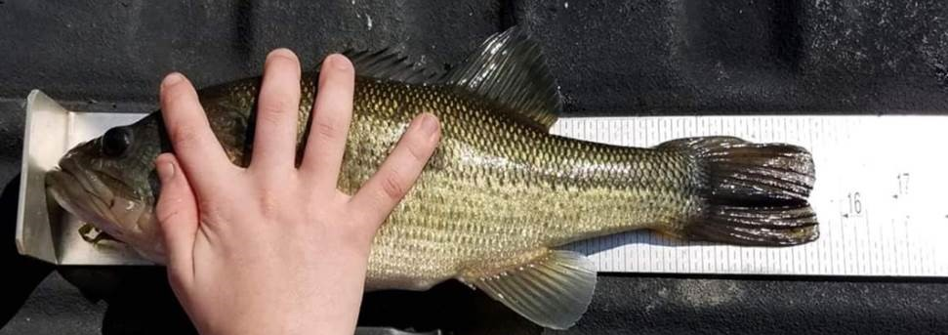
  - You will be given an eight letter/digit code for each event to display on an index card, or use preprinted form below, with your fish photograph. The code will be revealed one hour before the tournament begins and it will be posted to the Facebook 2020 4-H Fishing group that morning.
  - Index card must have District, County, youth name(s) (if a team), fish number, and eight-digit code. Cards that cannot be read will be disqualified. See example below:

Please print – must be legible!

Check tournament species: Bass Big Bass Option Crappie Catfish

District ________________ County _________________________

Fish Number: __________

8-digit code: _________________________
(posted 1 hour before tournament on FB 2020 4-H Fishing group page)

Angler Name 1: _____________________________________________________

(Complete below if registered as a bass team)

Angler Name 2: _____________________________________________________

Angler Name 3: _____________________________________________________

Angler Name 4: _____________________________________________________

(Complete below if entered in Big Bass Optional Tournament)
Fish length: _____________________ Fish girth: _________________________

- Optional Big Bass Contest:
- Youth entered in the Optional Big Bass contest will compete individually against other 4-H anglers across the state. Must be entered in 4-H Connect before start of tournament.
- Awards/prizes will be given to the top 3 big bass from entire tournament. When documenting your fish on notecard, be sure to add the fish length and girth to your card so that a replica can be made as part of the prize package for the top “big bass.”
  - Length is measured in inches from mouth to tip of tail, not the fork.
  - Girth is measured in inches around the fish at the widest part, usually right in front of the dorsal fin.

Crappie Tournament (individual event)
- Event Dates: May 9, 16, and 23.
- Times: 8:00 am to 3:00 pm - postings before or after times will be disqualified.
- Crappie Species for Judging: White and Black.
- Posting Limits: You may catch as many Crappie as possible and post them. Your longest 25 Crappie make up the winning length.
- Judging Criteria:
  - Fish must be photographed laying on a Check-It-Stik measuring board in addition to a completed note card or the optional form below. Check-It-Stiks can be purchased at Academy, on-line and at other fishing gear stores.
  - Mouth of fish must be touching the board and tail pinched. If measurement cannot be read from photograph, the entry will be disqualified. See example below:
Check-It-Stik

  - You will be given an eight letter/digit code for each event to display on an index card, or use the preprinted form below, with your fish photograph. The code will be revealed one hour before the tournament begins. It will be posted to the Facebook 2020 4-H Fishing group that morning.
  - Index card must have District, County, youth name, fish number, and eight-digit code. Cards that cannot be read will be disqualified. See example below:

Optional use instead of a note card – print, complete, and post with fish photograph.

Please print – must be legible!

Check tournament species: Bass Crappie Catfish

District ________________ County _________________________

Fish Number: __________

8-digit code: _________________________
(posted 1 hour before tournament on FB 2020 4-H Fishing group page)

Angler Name: _____________________________________________________

Catfish Tournament (individual event)
- Event Dates: June 5-6, 12-13, and 19-20.
- Times: 6:00 pm of day 1 to 6:00 pm of day 2 - postings before or after times will be disqualified.
- Catfish Species for Judging: Channel, blue and their hybrids and subspecies, and flathead.
- Posting Limits: Catch up to a daily bag limit of catfish during event hours. No more than 30 catfish will count.
  - Channel, blue and their hybrids and subspecies daily bag limit: 25 in any combination, with a minimum length of 12 inches.
  - Flathead daily bag limit: 5 with a minimum length of 18 inches.
- Judging Criteria:
  - Fish measuring smaller than 24 inches must be photographed laying on a Check-It-Stik measuring board in addition to a completed note card or the optional form below. Check-It-Stiks can be purchased at Academy, on-line and at other fishing gear stores.
  - Mouth of fish must be touching the board and tail pinched. If measurement cannot be read from photograph, the entry will be disqualified. See example below:
Check-It-Stik
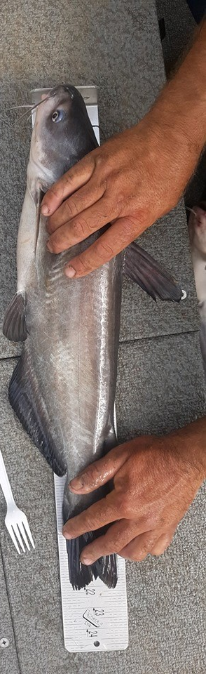

  - Fish larger than 24 inches should be measured on a 6-foot long 2x4 or 2x6 piece of wood. Lay the fish on the board and mark its length with a pen/pencil (see example below). Then measure from the beginning of the board to the mark using a tape measure in addition to a completed note card or the optional form below.

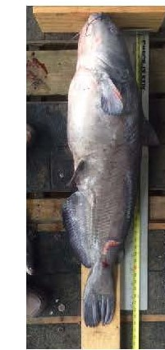
  - You will be given an eight letter/digit code for each event to display on an index card, or use the preprinted form below, with your fish photograph. The code will be revealed one hour before the tournament begins. It will be posted to the Facebook 2020 4-H Fishing group that evening.
  - Index card must have District, County, youth name, fish number, and eight-digit code. Cards that cannot be read will be disqualified.

Optional use instead of a note card – print, complete, and post with fish photograph.

Please print – must be legible!

Check tournament species: Bass Crappie Catfish

District ________________ County _________________________

Fish Number: __________

8-digit code: _________________________
(posted 1 hour before tournament on FB 2020 4-H Fishing group page)

Angler Name: _____________________________________________________

