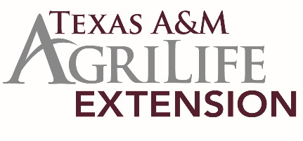
D8 4-H FOOD SHOW
2019 District 8 4-H Food Show
Project Experiences – Seniors Only

Name |  |  |  |  | County
Age Division |  |  |  |  | x | Senior
Category |  | Bread & Cereal |  | Fruit & Vegetable |  | Main Dish |  |  | Nutritious Snacks
Name of Recipe
Limit to current year’s experiences, including project activities, community service, and leadership. Limited to space below.

