Class 6
Mystery
Misty’s kids need a snack for after school while on the road to meetings and practices. She wants something easy to give the kids that are low in calories and sugars but her kids really love gummy snacks mostly. She also wants something that is worth the cost per serving. Please help her find something quick and easy and something they love.

Product 1 | Product 2 | Product 3 | Product 4
10 pouches per box  $8.98 | 8 pouches per box  $6.98 | 8 pouches per box  $8.98 | 1 box no pouches
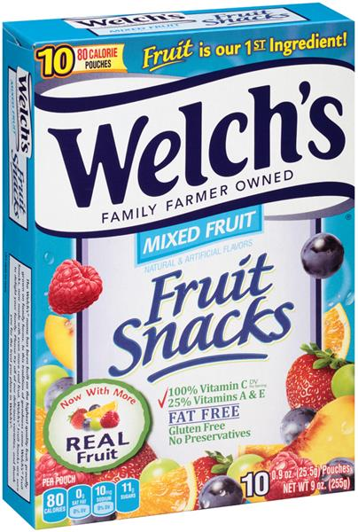 | 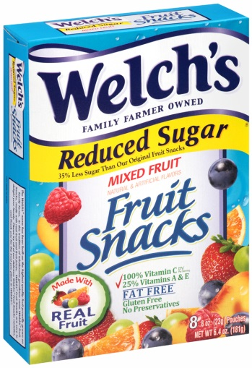 | 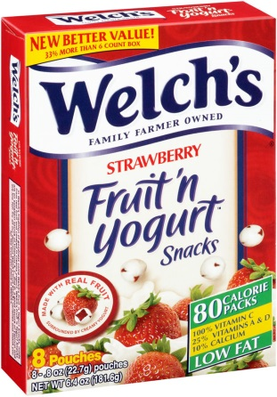 | 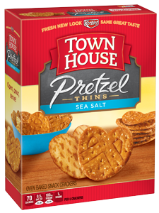
 |  |  | 