Class #2 (January 5th)
Western Boots

Ben is shopping for a new pair of boots. Ben would like a pair of boots that are fancy enough for him to wear to his State 4H speech and Horse shows, but comfortable enough to wear all day. He is looking for a boot that is easy to dance in but has a heel built for riding. Ben would also prefer his boots to be made with Ostrich and be square toed. Lastly Ben has $300 to spend.

Boot #1
Introducing the new Cavender's exotic square toe line! These boots are made in Nocona, Texas. Skins purchased from superior leather resources are top quality and our shaft leathers are soft and fashionable. Features include smooth ostrich leather full foot, 12" top with a deeper cut scallop, new welt leather, heavier threaded double welt stitching, 8-row newly designed stitch patterns, and new hole pulls with full embroidery around the edges that will coordinate with the stitching and/or piping. Don't miss out on these new Cavender's boots!
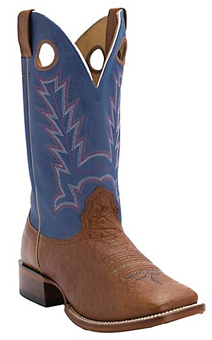

$189.99

Boot #2
These men's Roper boots feature a brown ostrich print faux leather foot and white faux leather 13" upper with traditional western style stitching. Padded sock insole, faux leather sole, 1/2" heel and double stitched welt.
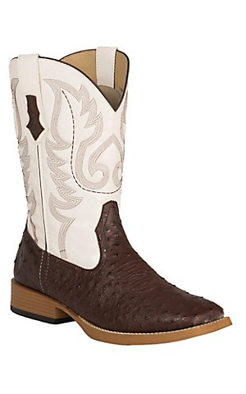
$89.99

Boot #3
Introducing the new Cavender's exotic square toe line! These boots are made in Nocona, Texas. Skins purchased from superior leather resources are top quality and our shaft leathers are soft and fashionable. Features include full quill ostrich leather foot with saddle vamp, 12" top with a deeper cut scallop, new welt leather, heavier threaded double welt stitching, 8-row newly designed stitch patterns, and new hole pulls with full embroidery around the edges that will coordinate with the stitching and/or piping. Don't miss out on these new Cavender's boots!
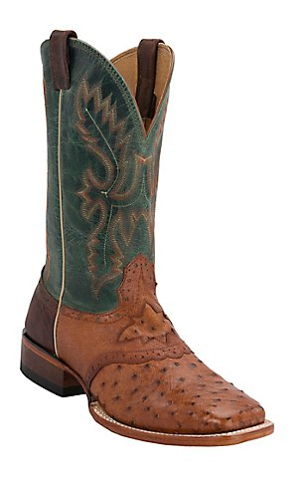
$329.99

Boot #4
Show a bit of your wild side with the new Wildstock boot from Ariat. Featuing punchy colors, a trend-right wide square toe and decorative collar design with pull holes, this boot is sure to impress. Plus, Ariat's ATS® technology provides superior comfort & flexibility for a fit and feel like no other!
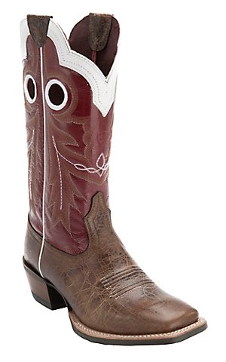
$229.99

