Class #1 (January 26th)
Printers
Cari needs a printer for her dorm room. She is always running late and needs something that will print fast. Cari has an ipad and iphone and loves to print pictures, coupons and assignments from her email. She is also the slideshow chair of her sorority and needs a printer that can scan photos she receives. She does not have space so she would like a smaller printer. She has $50 to spend.
Product #1  Canon PIXMA MG2920 Wireless Inkjet All-in-One Printer/Copier/Scanner, White  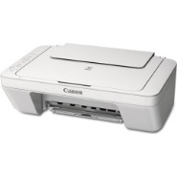 | Product #2  Canon PIXMA MG3522 Wireless Inkjet Photo All-in-One Printer  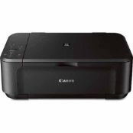 | Product #3  Canon MF212w Mono MFP Wireless Laser Multifunctional Printer/Copier/Scanner  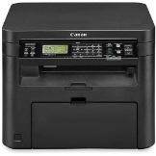 | Product #4  HP Deskjet 1512 Inkjet All-in-One Printer  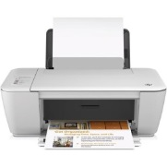
$39.00 | $49.00 | $109.98 | $49.00
The Canon PIXMA MG2920 all-in-one printer/copier/scanner is a compact wireless inkjet photo all-in-one printer that offers real convenience and remarkable affordability. Copy, scan and print from virtually anywhere around the house with its wireless capability. With a maximum color resolution of 4800 x 600 dpi, the Canon PIXMA MG2920 all-in-one printer/copier/scanner enables you to produce beautiful prints at home. | The MG3522 Canon PIXMA Wireless All-in-One Printer puts excellent quality and remarkable convenience in one compact package. Print gorgeous, borderless photos at home with a maximum print color resolution of 4800 x 1200 dpi The PIXMA MG3522 features AirPrint that allows you to print directly from your Apple iPhone, iPad or iPod touch wirelessly, while built-in WiFi technology allows you to print and scan wirelessly from virtually anywhere around your house. | The imageCLASS MF212w is an easy-to-use, wireless laser multifunction printer that produces professional output and features an array of mobile capabilities. With print, copy and scan needs combined into one compact device, your small office or home office will run efficiently. For simple mobile device printing, you can use Apple AirPrint, which allows you to print wirelessly from Apple iPad and iPhone. The Mopria Print Service is available for your mobile printing needs as well on an Android phone or tablet (Android version 4.4). | This HP Deskjet All-in-One Printer, 1512 offers easy printing, scanning and copying, with quick setup and straightforward operation, at an affordable price. Optional high-capacity cartridges help you print more for less.
Laser quality photos: 8 ppm black; 4 ppm color | Laser Comparable Speed - Up to 9.9 ppm black; Up to 5.7 ppm color | Laser Comparable Speed - Up to 24 ppm black; no color | Laser Comparable Speed - Up to 7 ppm black; Up to 4 ppm color
2-1-4-3

