Class #1 (Feb. 2nd)
Nutritious Snack Class

Luke is looking for a quick snack to eat when he gets home from school. In his Food and Nutrition Project, he has been learning to select healthy snacks. Help Luke find a nutritious snack.

1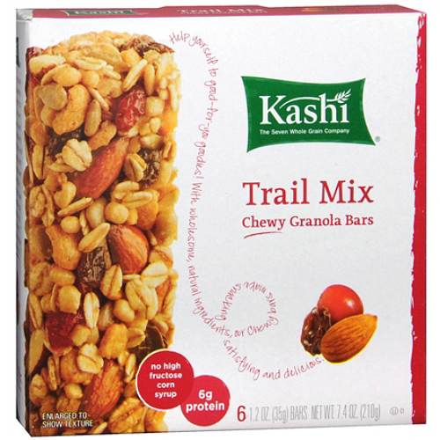 | 2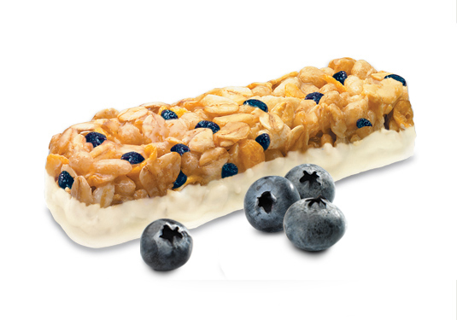 | 3  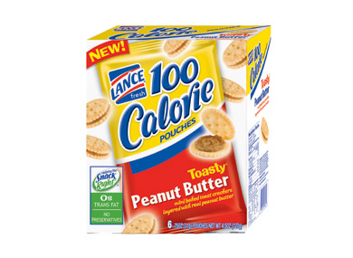 | 4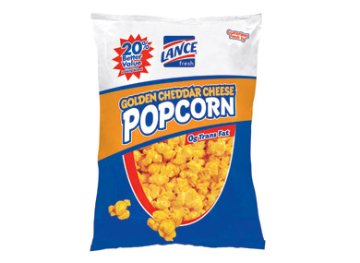
Nutrition Facts  Serving Size: 1 bar (35g)  Servings Per Container: 6  Amount per Serving  Calories Total 130  from Fat 45  Amount per Serving % Daily Value⁺  Total Fat 5 g 8%  Saturated Fat 0.5 g 3%  Cholesterol 0 mg  Sodium 90 mg 4%  Potassium 100 mg 3%  Total Carbohydrate 20 g 7%  Dietary fiber 4 g 16%  Soluble fiber 1 g  Insoluble fiber 3 g  Sugars 6 g  Protein 5 g  % Daily Value  Vitamin A IU 0  Vitamin C mg 0  Calcium mg 0  Iron mg 4% | Serving size 1 bar (35g)  Servings Per Container Amount per serving  Calories 150 Calories from Fat 40  %daily value  Total Fat 4.5g 7%  Saturated Fat 2.5g 12%  Trans Fat 0g  Polyunsaturated Fat 1g  Monounsaturated Fat 1g  Cholesterol 0mg 0%  Sodium 115mg 5%  Total Carbohydrate 25g 8%  Dietary Fiber 1g 5%  Sugars 11g  Protein 2g  Vitamin A 0%  Vitamin C 0%  Calcium 10%  Iron 2%  Calories 2,000 2,500  Total Fat less than 65g 80g  Sat. Fat less than 20g 25g  Cholesterol less than 300mg 300mg  Sodium less than 2,400mg 2,400mg  Total Carbohydrate 300g 375g  Dietary Fiber 25g 30g | Nutrition Facts  Serving Size: 1 Pkg (21g/Approx. 11 Crackers)  Calories: 100 Calories from Fat: 50  Amount per Serving % Daily Value  Total Fat 6g 9%  Saturated Fat 1.5g 7%  Trans Fat 0g 0%  Cholesterol 0mg 0%  Sodium 180mg 7%  Total Carbohydrate 12g 4%  Dietary Fiber 1g 5%  Sugars 2g  Protein 2g | Nutrition Facts  Serving Size: 1 oz  Calories: 160 Calories from Fat: 100  Amount per Serving % Daily Value  Total Fat 11g 18%  Saturated Fat 3g 16%  Trans Fat 0g 0%  Cholesterol <5mg 1%  Sodium 280mg 12%  Total Carbohydrate 13g 4%  Dietary Fiber 2g 8%  Sugars 2g  Protein 2g

Comparison
 | 1  Kashi Trail Mix Chewy Granola Bar | 2  Quaker Blueberry Yogurt Bar | 3  Lance 100 Calorie Toasty Peanut Butter Crackers | 4  Lance Golden Cheddar Cheese Popcorn
Calories | 130 | 150 | 100 | 160
Total Fat | 5g | 4.5g | 6g | 11g
Saturated Fat | .5g | 2.5g | 1.5g | 3g
Sodium | 90mg | 115mg | 180mg | 280mg
Total Carbohydrates | 20g | 25g | 12g | 13g
Dietary Fiber | 4g | 1g | 1g | 2g
Sugar | 6g | 11g | 2g | 2g
I placed this class of Nutritious Snacks 1 – 3 – 2 – 4.
Luke was looking for a nutritious after school snack. Calories, total fat, saturated fat, sodium, total carbohydrates, dietary fiber and sugar were all factors to consider.
I placed 1 over 3 because 1 the Kashi Trail Mix Chewy Granola Bar was the highest in dietary fiber at 4g. Granted 3 the Peanut Butter Crackers were 30 calories lower and the total carbohydrates were 8 g lower, I criticize that the total fat was 1 g higher, saturated fat was 1g higher and sodium was 90mg higher than the Kashi Granola Bar.
I placed 3 over 2 because 3 the Peanut Butter Crackers were lower in calories at 100 calories per serving . Granted 2 in lower in total fat by 1.5g and lower in sodium by 65g, I criticize that the total carbohydrates are 13g higher, saturated fat is 1g higher and sugar is 9g higher than the Peanut Butter Crackers.
I placed 2 over 4 because 2 is lower in calories at 150 calories per serving. Granted 4 is 12g lower in total carbohydrates and 9g lower in sugar, I criticize that the total fat is 7.5g lower, saturated fat is .5g lower, and sodium is 165mg lower in the Yogurt Bar.
I placed 4 last because it was the highest in calories at 160, total fat at 11g, saturated fat at 3g, and sodium at 280mg.
Therefore I placed this class of Nutritious Snacks 1 – 3 – 2 – 4.

