Class #1 (January 5th)
Jeans
Vanessa is a college student who is very athletic and has no figure/curves and needs a pair of jeans to wear to school. She prefers darker colored jeans because they fit better with her shirts. Please help her find a great pair of jeans. She has $50 to spend.
Jean #1 Gap | Jean #2 Tommy Hilfiger | Jean #3 Levi’s | Jean #4 Gap
$42 | $63 | $15 | $49
Cigarette Jeans | 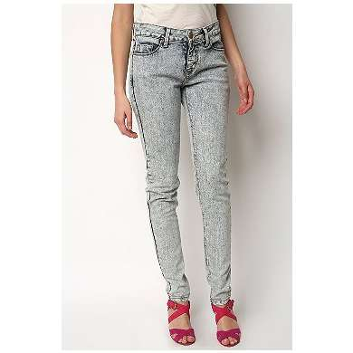  Cigarette Jeans | 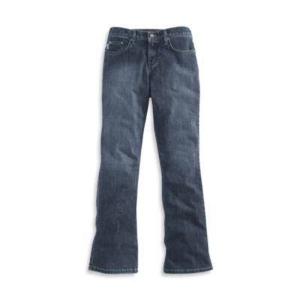  Stretch boot cut | 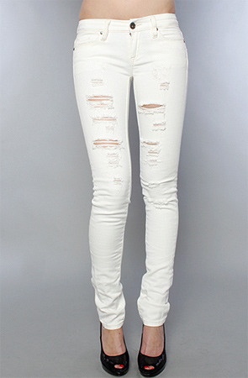  Skinny Jeans
Black | Stonewashed | Blue | White

Placing:
1-4-3-2
1: Cigarette Jeans preferred for athletic types, dark, $42 (less expensive than #4)
4: Skinny jeans also preferred for athletic types, light colored (wanted dark colors), one of the most expensive pairs of jeans at $49
3: Least expensive, stretch is not preferred for non-figured body types, boot cut and straight legged from hip to knee not as preferred for athletic types
2: Cigarette jean, light colored (preferred dark), and was out of price range.

