Class #2 (Jan. 12th)
Digital Cameras
Diedra is starting her own wedding photography business. She needs a nice SLR camera however since this will be more of an extra job and she does not know how long she will keep it up, she only wants a simple SLR and she only has $700 to spend. Diedra would like a HD video option with the camera as well so she can video the ceremonies.
Product #1 | Product #2 | Product #3 | Product #4
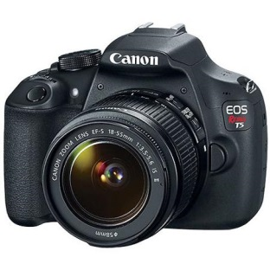 | 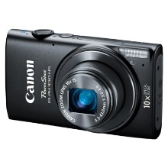 | 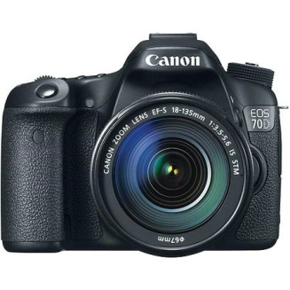 | 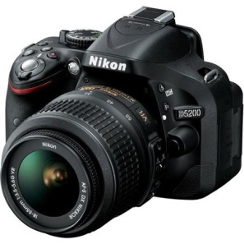
Canon Black EOS Rebel T5 Digital SLR Camera with 18 Megapixels and 18-55mm Zoom Lens Included | Canon PowerShot Elph 330 HS 12.1MP Digital Camera with 10x Optical Zoom | Canon Black EOS 70D 20.2 MP Digital SLR Camera Kit, Includes 18-135mm Lens | Nikon D5200 Digital SLR Camera with 24.1 Megapixels and 18-55mm Lens Included (Available in multiple colors)
$499.99 | $149.99 | $1,349 | $646.95
Canon Black EOS Rebel T5 Digital SLR Camera:  18 megapixel resolution with high-quality still images and video recordings  The Canon EOS Rebel T5 Digital SLR Camera features 1080p Full HD Movie Recording, Face Detection Technology, Optical Image Stabilization | Share with Powerful Style. Radiant in a sleekly rounded new design, the PowerShot ELPH 330 HS boasts enhanced built-in Wi-Fi® that enables you to comment on photos and share them to social networking sites.  Megapixels: 12.1 Megapixels  Zoom: 10.0 X Optical- 24mm  Camera Features: Face-activated self timer, Self Timer  Flash Features: Slow-Sync Flash, Auto On/Off  Lens Features: Wide Angle  Display Size: 3.0 "  ISO Equivalent: 3200, 800, 200, 1600, 100, 400  Battery Required, included: 1 lithium ion | Canon Black EOS 70D 20.2 MP Digital SLR Camera Kit, Includes 18-135mm Lens:  20.2 effective megapixel resolution with high-quality still images and video recordings  The Canon EOS 70D Digital SLR Camera Kit features Auto and Standard Effects 720p HD Movie Recording, Face Detection Technology  Canon EF-S 18-135mm standard zoom lens with up to 0.21x zoom  Equivalent to a 29-216mm lens on an analog camera with One-Shot AF, AI Focus AF, Predictive AI Servo AF | Nikon D5200 Digital SLR Camera:  The Black NIkon Digital SLR Camera features 24.1 megapixel resolution with high-quality still images and video recordings  Featuring Scene Modes, Dust-Reduction System, 1080p Full HD Movie Recording  Nikon 18-55mm zoom lens  With TTL Phase Detection, Auto Focus, Single-Servo AF, Continous-Servo AF, Glass Lens  3.0" TFT LCD screen with image editing features  Featuring Brightness Adjustment, color TFT LCD screen  Built-in flash with Auto Pop-Up, Red-Eye Reduction, Auto Slow Sync, Fill-Flash

4-1-2-3

