Class #1 (January 12th)
Computer Scenario
Product 1 | Product 2 | Product 3 | Product 4
HP Envy 15 | Inspiron 15 5000 Series (Intel®) Non-Touch | Acer Aspire E5-571-56UQ 15.6-Inch Laptop (Titanium Silver) | Apple MacBook Air MD760LL/B 13.3-Inch Laptop (NEWEST VERSION)
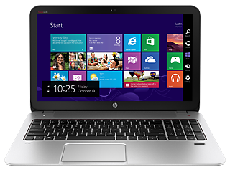 | 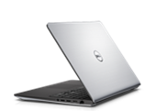 | 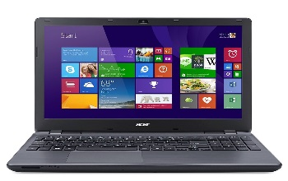 | 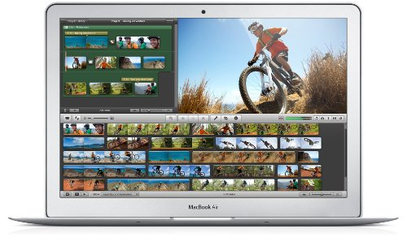
$ 599. ⁹⁹ | $699.99 | $499.99 | $899.99
Full-size keyboard with 10-key keypad on the right, 3.5 pounds | Full size, spill-resistant keyboard (backlit version standard), 6 pounds | Full size keyboard, 5.5 pounds | 3 pounds
Windows 8 or other Windows operating systems available, 6 hour battery | Windows 7 Home Premium, 2 hour battery | Windows 8.1, 7-hour battery life | OS X Mavericks; Up to 12 hours of battery life
Intel(R) Core(TM) processors and AMD processors, 1.6 GHz Processor (3 MB Cache) | 4th Generation Intel® Core™ i5, 1.4 GHz Processor | Intel Core i5-4210U 1.7 GHz Processor (3MB Cache) | 1.4 GHz Dual-Core Intel Core i5 (Turbo Boost up to 2.7GHz) with 3MB shared L3 cache
15.6" HD diagonal displays | 15.6 inch LED Backlit Display with Truelife and HD resolution (1366 x 768) | 15.6-Inch Screen, Intel HD Graphics 4400 | 13.3-inch LED-backlit glossy widescreen display; Intel HD Graphics 5000
4GB | 8GB | 8GB | 16GB
Robert is in need of a computer that he can use to do his school work at home and at school. He has to write papers using Microsoft Word, practice math facts on the Internet, and send his teacher weekly e-mails with his work attached. On weekends Robert needs to unwind. He would like to play Minecraft & Terraria, watch videos & listen to music, and clean up photos for art contests using this new computer. Robert has a budget of $800, but will also need to use some of his budget to purchase a printer. Please help Robert find a computer that meets all of his needs.

